Bridgwater Bay PCN
Clinical Director: Dr Catherine Lewis, Principal GP, Victoria Park Medical Centre

Cannington Health Centre, Cranleigh Gardens Medical Centre, East Quay Medical Centre,
North Petherton Surgery, Polden Medical Practice, Quantock Medical Centre, Redgate Medical Centre, Somerset Bridge Medical Centre, Taunton Road Medical Centre, Victoria Park Medical Centre
PCN NEWSLETTER

Coronavirus (COVID-19) - If you are concerned that you may have coronavirus or may have come into contact with someone who has, the NHS 111 online service has been created and this can be accessed at: https://111.nhs/service/covid-19. Only if you do not have access to the internet should you telephone 111, for coronavirus (covid-19) enquiries.

Temporary change to appointments

During the present time GP surgeries are reducing the number of patients attending their practices. This could mean that you may have a telephone review and/or consultation with your GP or Nurse instead of a face to face appointment.

Pharmacy Preference

If you do not yet have an electronic pharmacy nomination for your prescriptions to be sent to please can we encourage you to nominate one as this will also reduce the number of patients attending practices.

Stay at home if you have coronavirus symptoms
- a high temperature
- a new, continuous cough
If you live alone and you have symptoms, however mild, stay at home for 7 days from when your symptoms started.
If you live with others and you are the first in the household to have symptoms, then you must stay at home for 7 days, but all other household members must stay at home for 14 days. The 14 day period starts from the day when the first person in the house became ill.
Do not go to a GP surgery, pharmacy or hospital. This action will help protect others in your community whilst you are infectious.
Plan ahead and ask others for help to ensure that you can successfully stay at home. Ask your employer, friends or family to help you to get the things you need to stay at home.
Stay at least 2 metres (about 3 steps) away from other people in your home whenever possible.
Sleep alone, if that is possible.
Wash your hands regularly for 20 seconds, each time using soap and water.
Stay away from vulnerable individuals such as the elderly and those with underlying health conditions as much as possible.
You do not need to call NHS 111 to go into self-isolation.
Please download the NHS app or access the NHS website (www.nhs.uk) for more detailed information and instructions.
If your symptoms worsen during home isolation or are no better after 7 days contact NHS 111 online www.111.nhs.uk.
If you have no internet access, you should call NHS 111. For a medical emergency dial 999.

page 2
PCN NEWSLETTER

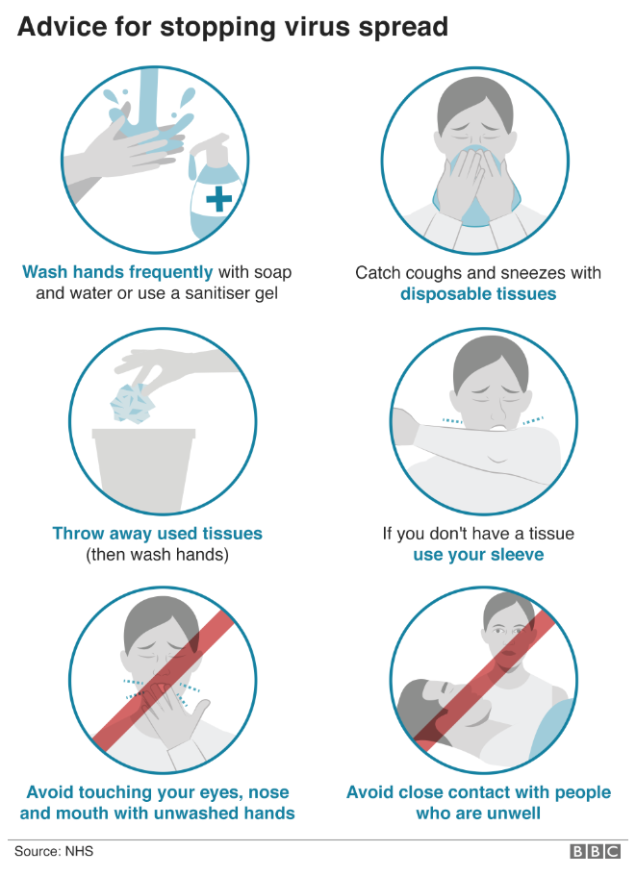

Reducing the number of patients attending the practice is to reduce the risk of spreading infection during the current pressures with coronavirus.

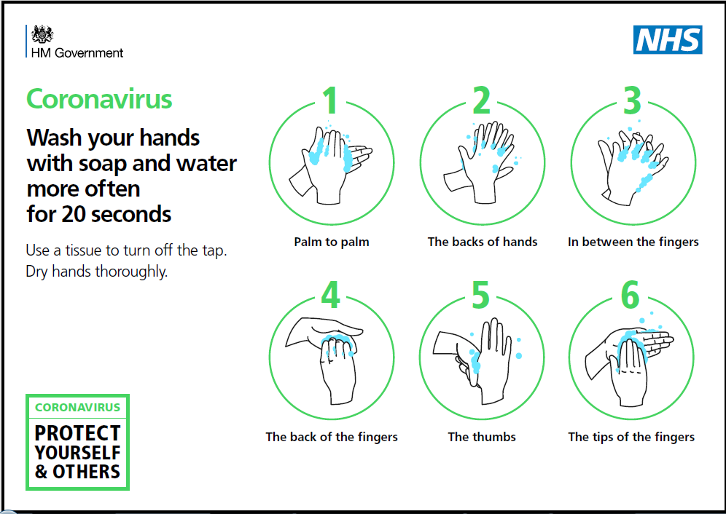

Online Services

Have you considered signing up to online access, a convenient way in which to view your medical record, test results and order repeat medication. This service is available 24 hours a day, 7 days a week.

